Macintosh HD:Users:jamesvandeberg:Desktop:New Patient Information SA ORTHO.pdf

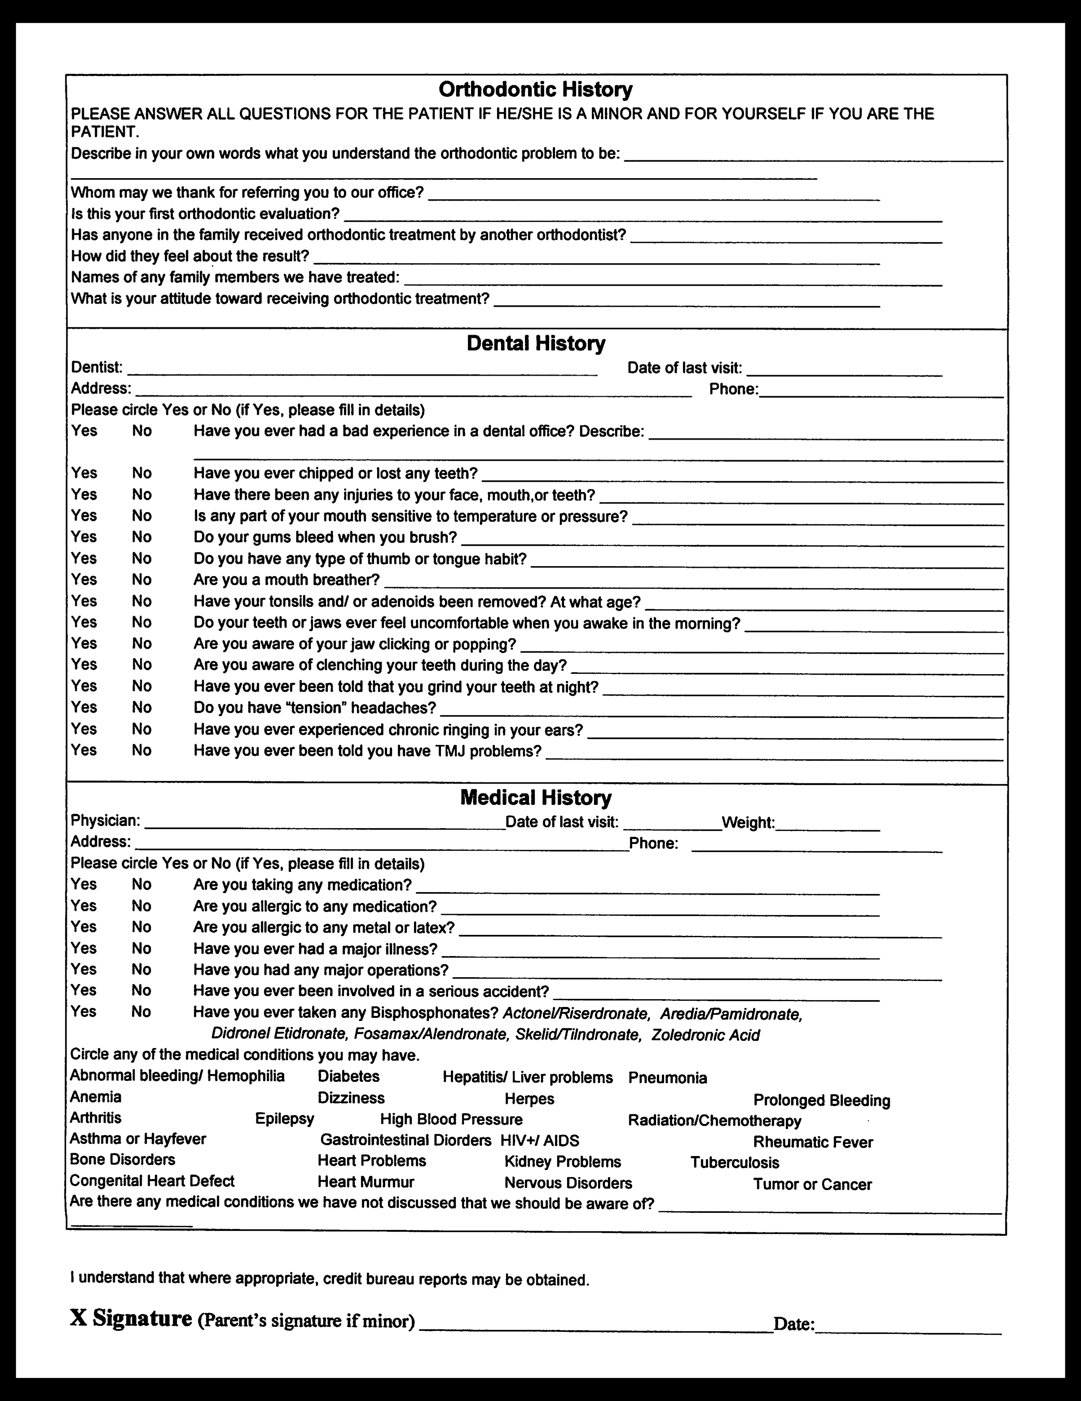

p

PRIVACY CONSENT

This form is optional under the new patient privacy regulations recently issued by the United States Department of Health and Human Services. We have elected to use this form. Prior to commencing your orthodontic treatment, you should review, sign and date this form. Your protected health information (i.e., individually identifiable information such as names, dates, phone/fax numbers, email addresses, home addresses, social security numbers, and demographic data) may be used in connection with your treatment, payment of your account or health care operations (i.e., performance reviews, certification, accreditation and licensure).

You have the right to review our office’s privacy notice prior to signing this consent, a copy of which was given to you with this Consent.

You have the right to request restrictions on the use of your protected health information. However, we are not required to, and may not, honor your request. We may amend the attached privacy notice at any time. If we do, we will provide you with a copy of the changes, and the changes may not be implemented prior to the effective date of the revised notice.

You may revoke this consent at any time in writing. However, such revocation will not be effective to the extent that any action has been taken in reliance on this consent. Thank you for your cooperation. Please let us know if you have any questions.

Signature

Date

PATIENT PHOTO RELEASE

Patient Name

The above named patient (or parents/legal guardian) of San Antonio Orthodontics, consent to authorized the use and reproduction of photographs and audiovisual material whenever print or electronic format. I understand that these pictures, name, and only may appear in such publicity material for promotional and educational purposes only.

I accept to having my photo released

I decline to have my photo released

Signature